Coinz WORK.STATION
Assembly Instructions


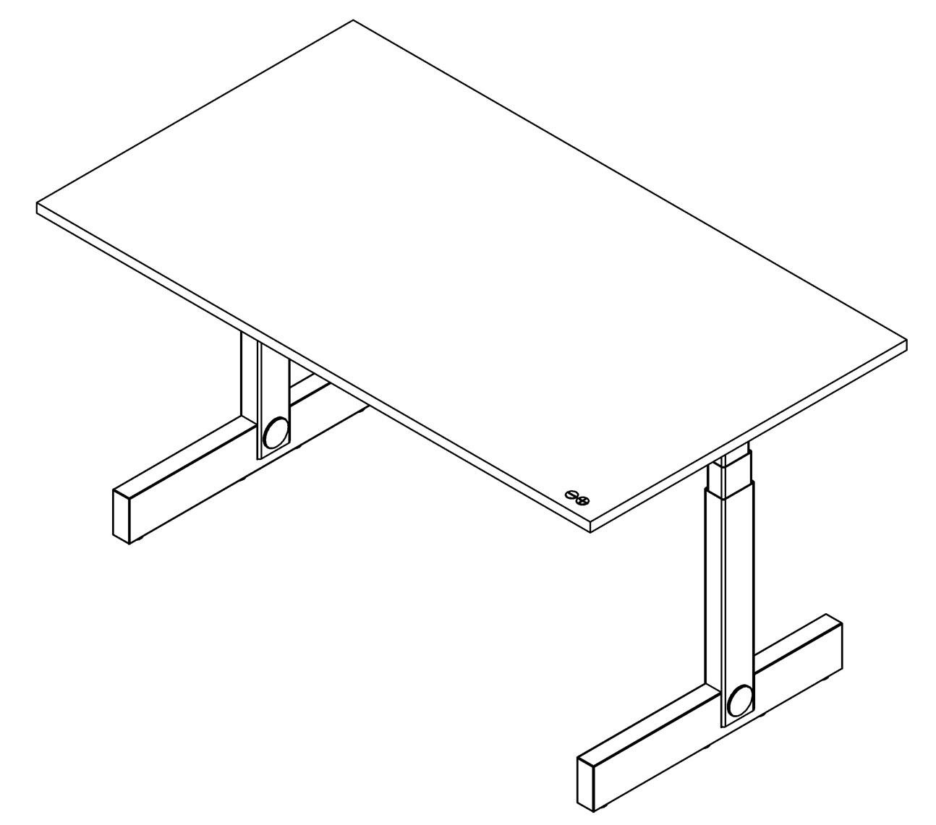
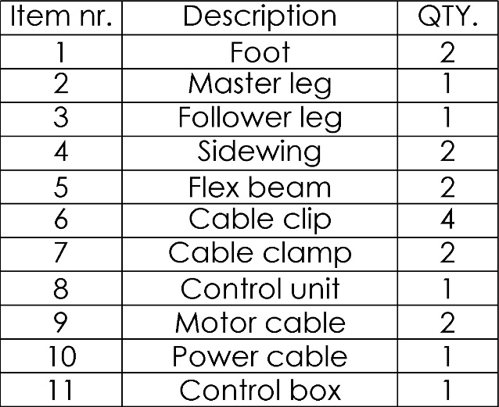
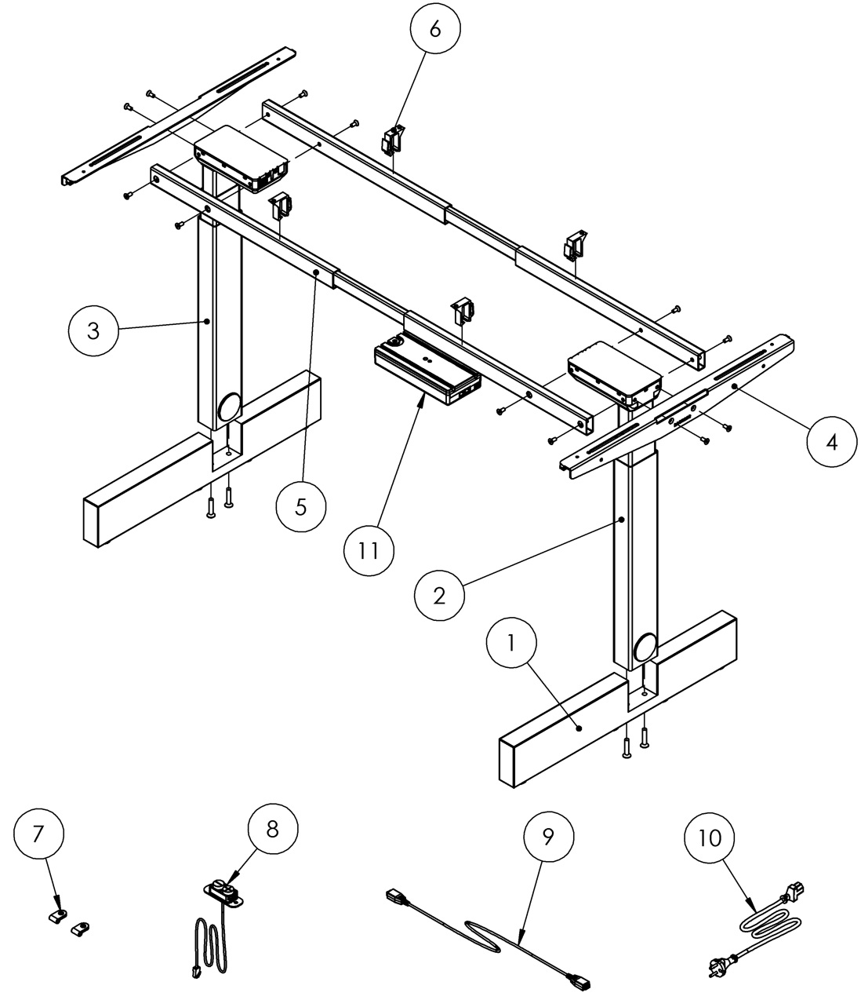

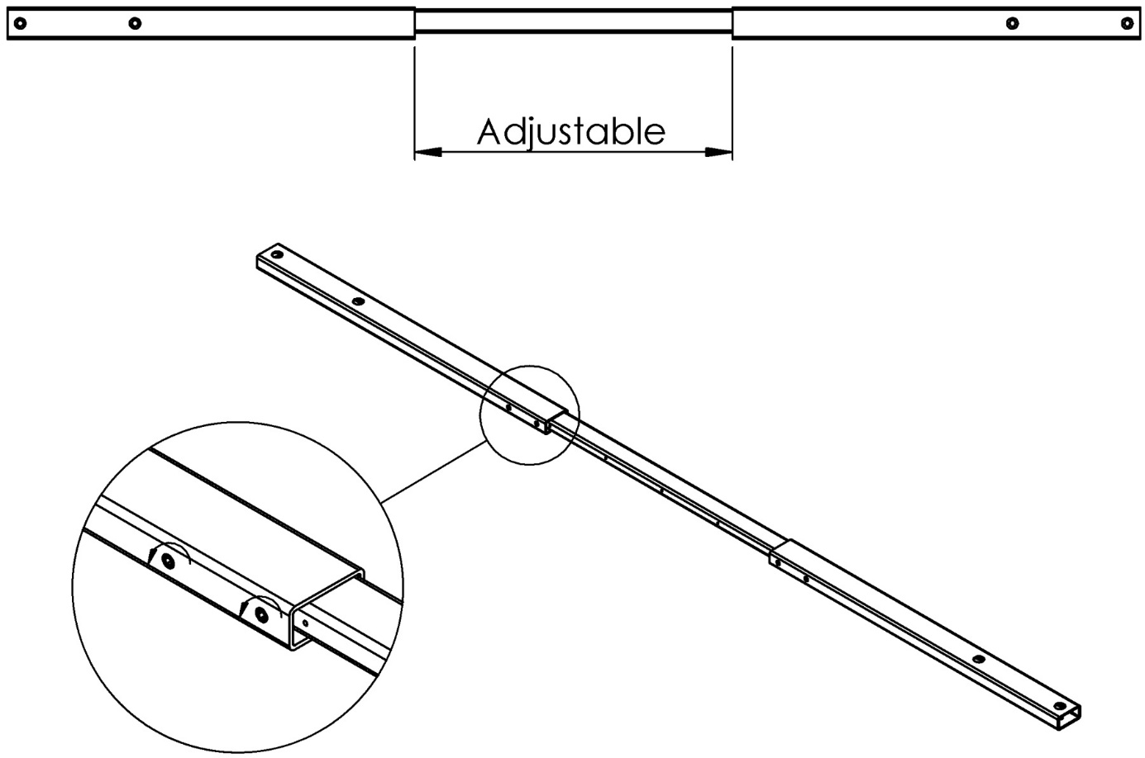
Make sure to loosen the screws before adjusting
the length of the Flex beams.
Tighten them again when the top has been
adequately mounted on the frame.

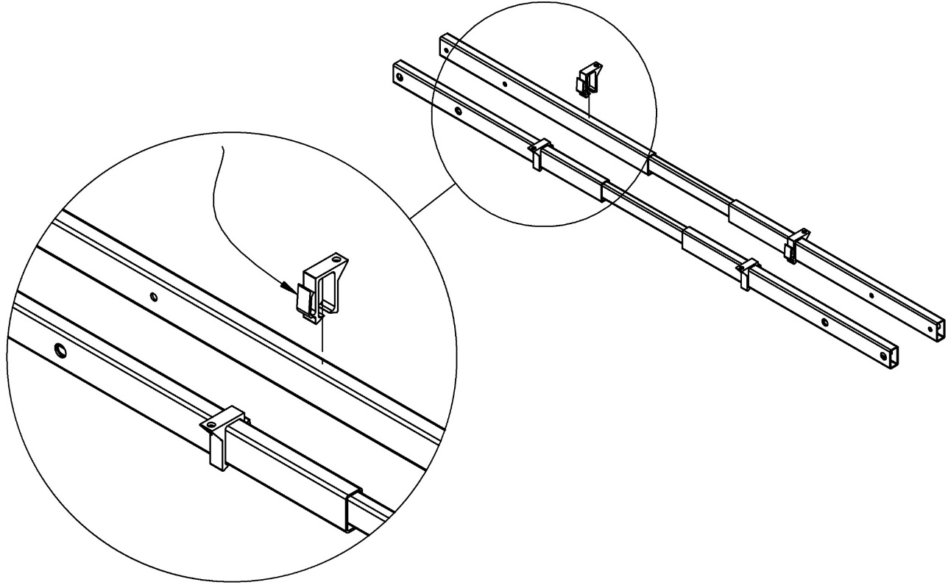
Note: The cable holders on
the Clips should be on the
inside (between) the
Flexbeams.

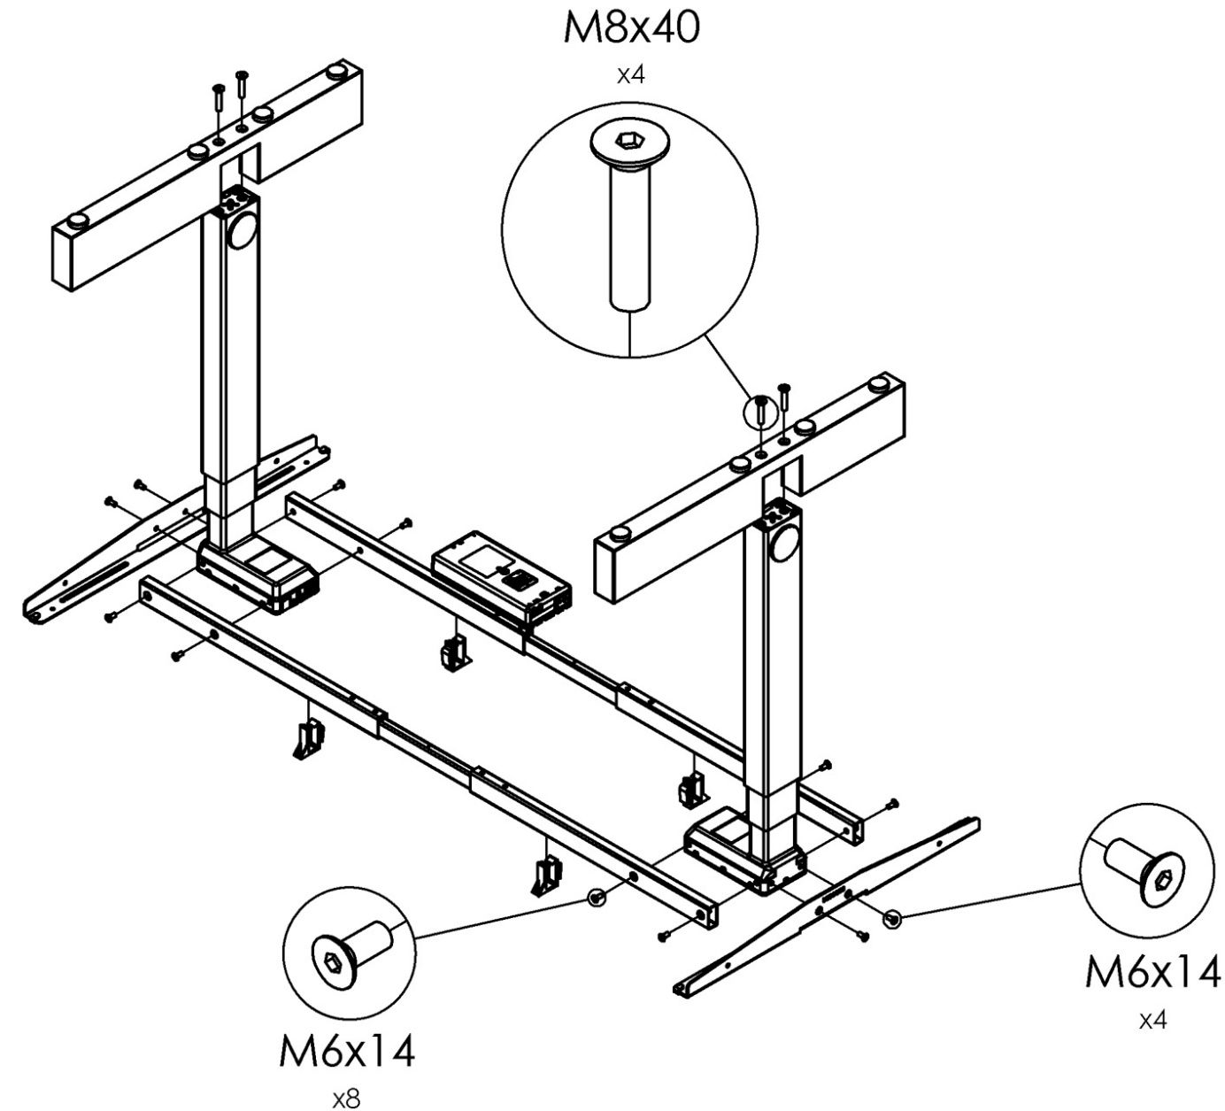
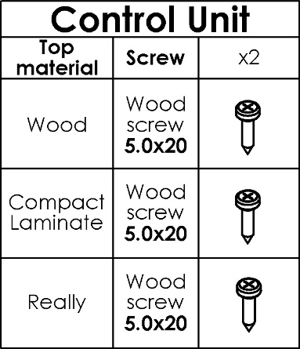

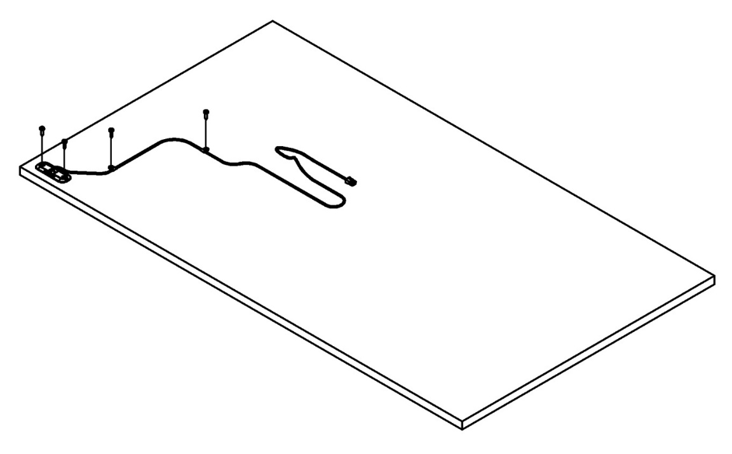

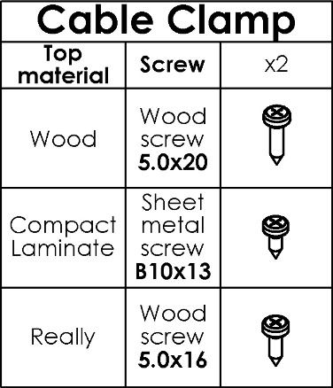
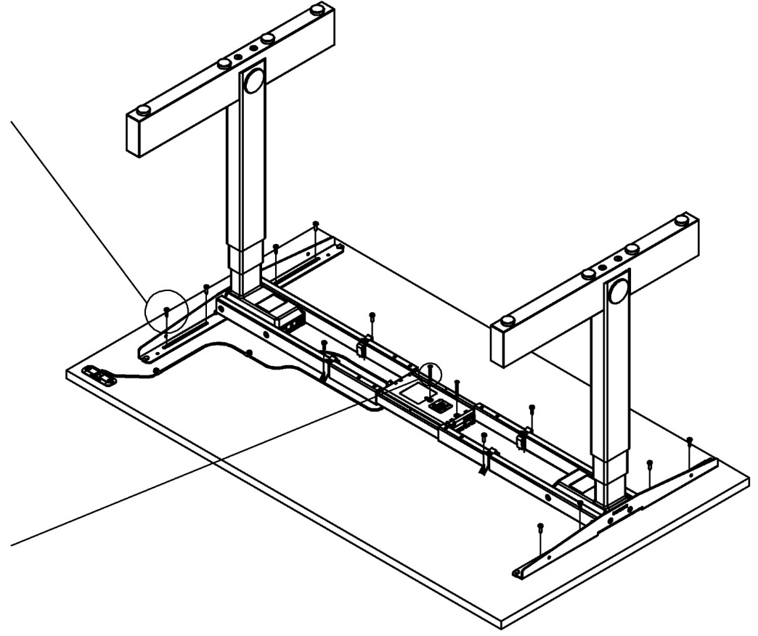
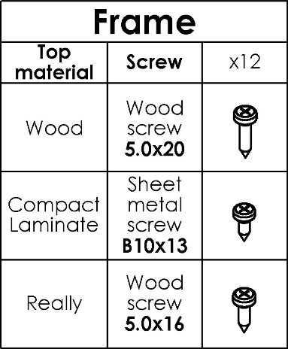

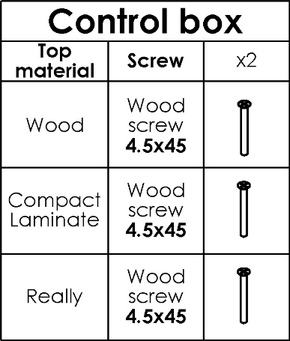

Control Box
Loop the power cable to prevent it
from coming loose by accident.

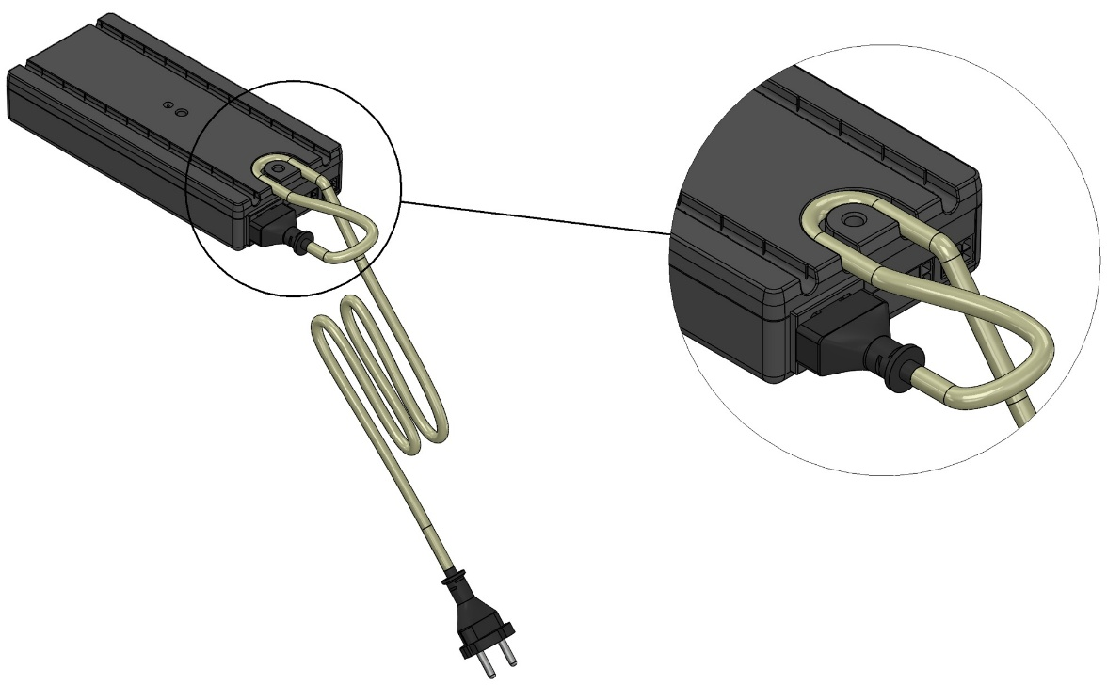
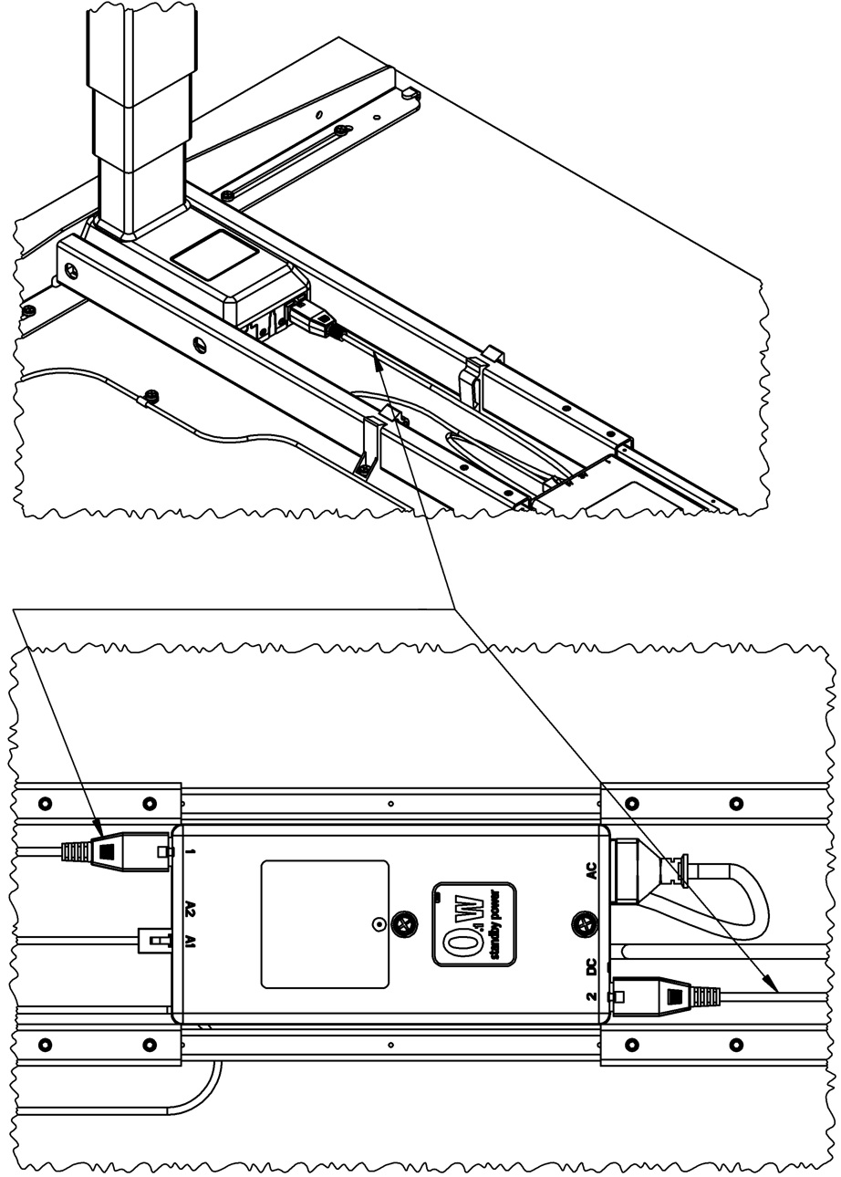

Connect the motor cable
between control box and legs.

Use the cable clips on the inside between the beams
to tighten up and secure any redundant cable length.
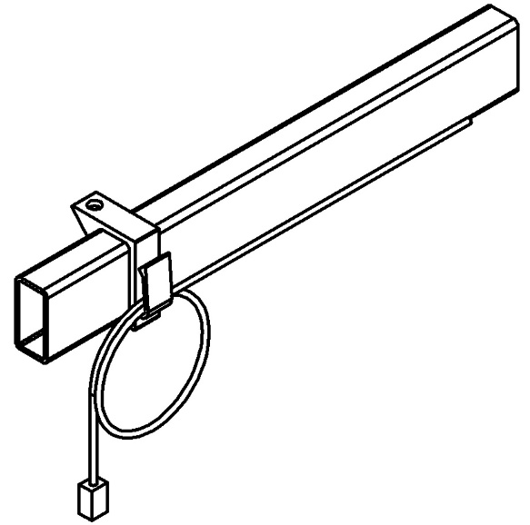
Coinz Station
Repairs and Replacement of Parts
Repairs may be required for components such as the tabletop, surface coating of the feet, control panel, or lifting columns.
For assistance, please contact Ragnars customer service.
Replacement parts can be installed by the customer by following the assembly instructions in this document.
Repairs involving the lifting columns (electric legs) must, for safety reasons, be carried out by a certified service technician.
Tools needed: Screwdriver (or electric screwdriver)
Disassembly
Disassembly should be carried out by following the assembly instructions in reverse order. Ensure that the power supply is disconnected before starting.

